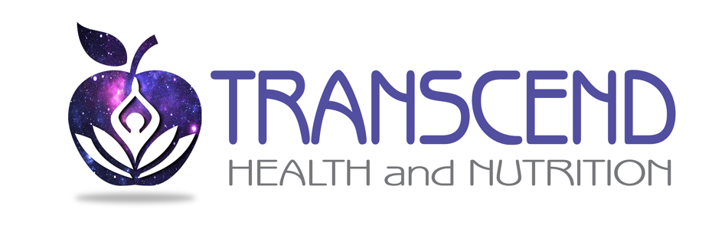
Bio-energetic Testing Consent and Disclaimer Form
- I understand that the technology used at Transcend Health and Nutrition, LLC for Qest4 bio-energetic testing is not a medical device.
- I recognize that I must seek the advice of my primary care physician or other qualified health care provider with any questions I may have regarding a medical conditions or treatment and before undertaking a new health care
- Additionally, I acknowledge that I should not disregard professional medical advice or delay going to the doctor or seeking advice based on the results of my Qest4 bio-energetic test.
- The Qest4 Bio-Energetic test is a non-invasive process that helps customer and practitioner understand pertinent information about your body’s systems and functions. The main objective of the scan is to understand energetic imbalances inside the body and create a functional care plan to bring the body back into balance.
- I understand that Kristen Hendrix is not a medical doctor. I fully recognize that this consultation is not for medical diagnostic purposes or treatment measures.
- The services provided include: healthy lifestyle education, natural health alternatives, nutritional counseling, weight loss counseling, homeopathic counseling, supplement, vitamin and minerals education and recommendations, emotional energetic blocks, neurolinguistic programming etc.
- I understand the services provided do not involve the diagnosing, treatment, or prescribing of remedies for disease in place of medication.
- I understand that the health intake forms do not provide medical diagnosis and that the bio-energetic practitioner may recommend further medical testing.

- If I suspect that I need further medical intervention, I understand I should consult my physician. I give my permission for the bio-energetic practitioner to evaluate the results of the Qest4 scans. I understand in doing so the bio-energetic practitioner will give me information about myself and make recommendations based on the Qest4 screening. I understand that the testing technician will not pass judgments on prescribed medications. Any decision to follow through with the recommended program is my own decision and I hold the bio-energetic practitioner harmless.
- I fully understand that the bio-energetic practitioner is not a medical doctor and I am not here for any medical diagnostic purposes or treatment procedures.

________________
Please initial here that you have read and understand these terms and conditions

